Lab 7: Explore partitions with Iceberg

Estimated completion time
- 30 minutes

Learning objectives
- In this lesson, you will explore partitioning with Iceberg tables using a public bicycle-sharing dataset known as Bluebikes. You will learn how to access these tables and partition them in different ways. You will also compare how the Hive table format differs from the Iceberg table format, deploying a series of tests and checking the results.

Prerequisites
- Student setup - Lab 1: Create student account

Activities
- Prepare for the exercise
- Review Bluebikes dataset
- Inspect column types
- Count number of stations in each district
- Partition table by district
- Reorder columns to fit Hive requirements
- Partition Iceberg table without changing order of columns
- Copy non-partitioned table data into Iceberg table
- Investigate files
- Query partitions table
- Reformat output
- Query trips table
- Partitioning start_time field
- Understanding conditional logic and the WHERE clause
- Create partitioned table
- Copy data into table
- Apply conditional logic using WHERE clause on source table
- Compare results with newly partitioned table

Step 1 - Prepare for the exercise
- Sign in and verify the students role is selected in the upper-right corner.
- Ensure the aws-us-east-1-free Cluster is reporting a Status of Running.

Note: If you did not previously create a schema, execute the following SQL statement. Make sure that you replace yourname with your actual name, or another identifier that you prefer. Only use lowercase characters and numbers; no special characters or spaces.

CREATE SCHEMA students.yourname;

Step 2 - Review Bluebikes dataset
For this lab, you will use the publicly available Bluebikes - Hubway dataset. Read more information about Blue Bikes Boston, a bicycle-sharing program based in Boston since 2011.

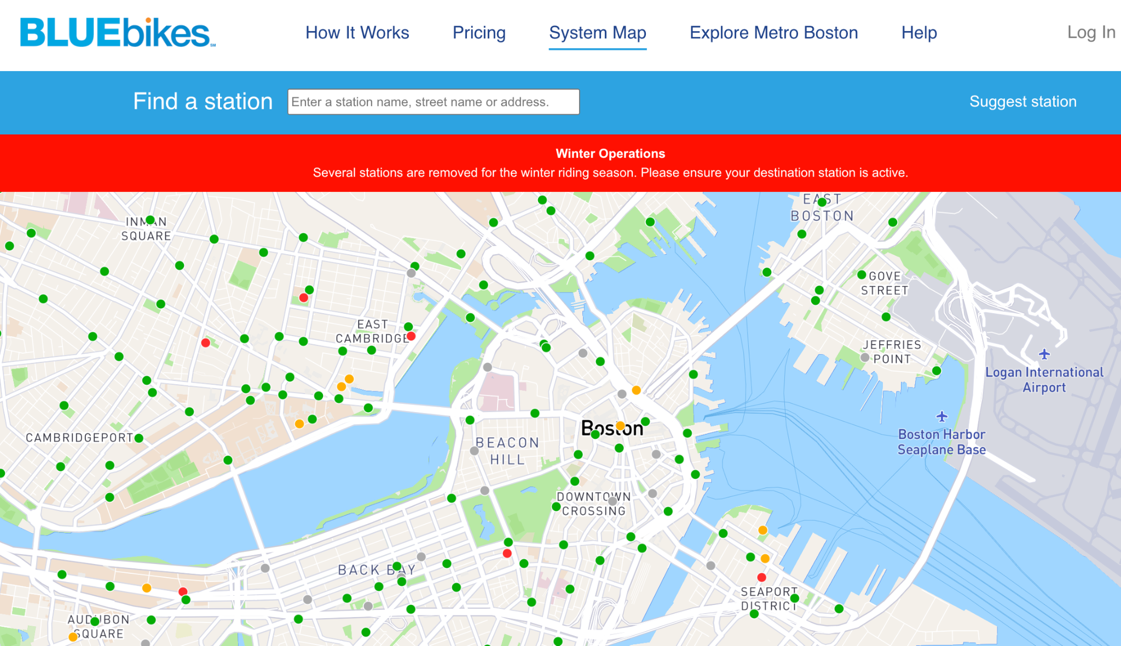

The two tables you will use are:
- lakehouse.bluebikes.stations
  - A list of the current docking stations available
  - Data current as of December 5, 2022
- lakehouse.bluebikes.trips
  - Transactional records of bike trips from start to finish
  - Contains all rides from January - November of 2022

Note: There are tables present whose names begin with raw_ as well. The two tables above are examples of transformed/enriched/augmented/cleansed/etc. data that will be explored later in the data pipelining workshop.

Step 3 - Inspect column types
Using the aws-us-east-1-free cluster, familiarize yourself with these two tables by inspecting the column types and running a few queries to see some sample data. More details on specific columns can be found at Bluebikes System Data | Blue Bikes Boston.

Step 4 - Count number of stations in each district
Determine how many stations are assigned to each district. To do this, use a SELECT statement in conjunction with the count(), GROUP BY, and ORDER BY modifiers to introduce the desired logic.

SELECT
district,
count() as nbr_stations
FROM
lakehouse.bluebikes.stations
GROUP BY
district
ORDER BY
nbr_stations DESC;

Step 5 - Partition table by district
Run the following code to see the full CREATE TABLE statement for the stations table.

SHOW CREATE TABLE lakehouse.bluebikes.stations;

Modify the output to create a new table partitioned by district in this first example. Notice how the SQL below specifically calls for a partitioning strategy by district.

USE students.yourname;

CREATE TABLE stations_orc_partby_district (
station_nbr varchar,
name varchar,
latitude decimal(8, 6),
longitude decimal(9, 6),
district varchar,
public boolean,
total_docks smallint,
deployment_year smallint
)
WITH (
format = 'ORC', partitioned_by = ARRAY['district'], type = 'HIVE'
);

You should receive an error message similar to the image below. In this case, the partition keys must be the last column in the table, and listed in the same order as the table properties. Since this is not the case, the system generates an error.

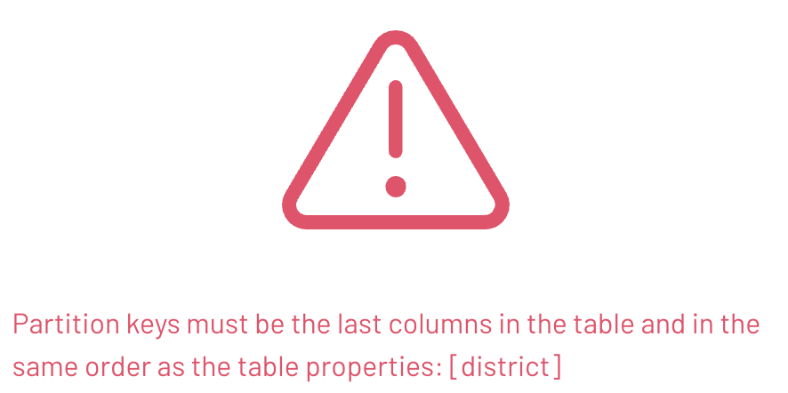

Step 6 - Reorder columns to fit Hive requirements
The Hive table format is very particular about the placement of the partition column(s). To fix this, put it as the last column in the list using the code below.

CREATE TABLE stations_orc_partby_district (
station_nbr varchar,
name varchar,
latitude decimal (8, 6),
longitude decimal (9, 6),
public boolean,
total_docks smallint,
deployment_year smallint,
district varchar
)
WITH
(
format = 'ORC', partitioned_by = ARRAY['district'], type = 'HIVE'
);

Note: You can populate this new table for investigation, but it is not necessary for the remainder of the exercise. The point to remember is the Hive table format requires the partition column(s) to be the last column(s) and in the same order.

Step 7 - Partition Iceberg table without changing order of columns
Use the following Data Definition Language (DDL) to create a partitioned Iceberg table. Note that the code below will partition the column without changing their order.

CREATE TABLE stations_p_district (
station_nbr varchar,
name varchar,
latitude decimal (8, 6),
longitude decimal (9, 6),
district varchar,
public boolean,
total_docks smallint,
deployment_year smallint
)
WITH
(
type = 'iceberg',
format = 'ORC',
partitioning = ARRAY['district']
);

The error that results is caused by subtle differences in supported data types between table formats. See Iceberg type mapping for more information.



Step 8 - Copy non-partitioned table data into Iceberg table
Review the integer data type family documentation and see if you can just go up to a wider data type. Hint: use integer instead as shown in the revised DDL.

CREATE TABLE stations_p_district (
station_nbr varchar,
name varchar,
latitude decimal (8, 6),
longitude decimal (9, 6),
district varchar,
public boolean,
total_docks integer,
deployment_year integer
)
WITH
(
type = 'iceberg',
format = 'ORC',
partitioning = ARRAY['district']
);

Now copy the non-partitioned table’s data into the partitioned Iceberg table you created.

INSERT INTO
stations_p_district
SELECT
*
FROM
lakehouse.bluebikes.stations;

Step 9 - Investigate files
Take a look at the underlying files that were created using the code below.

SELECT
substring(file_path, position('/data/' IN file_path) + 6),
record_count
FROM
"stations_p_district$files";

You were returned 14 rows as shown below. When you look closely you will see that the start of each of the file names begin with district=. These are the partitions that were created for the 14 unique distinct values you determined in the count of stations by district query you ran in Step 4. Additionally, the totals from that step are also referenced appropriately in the record_count column values below.

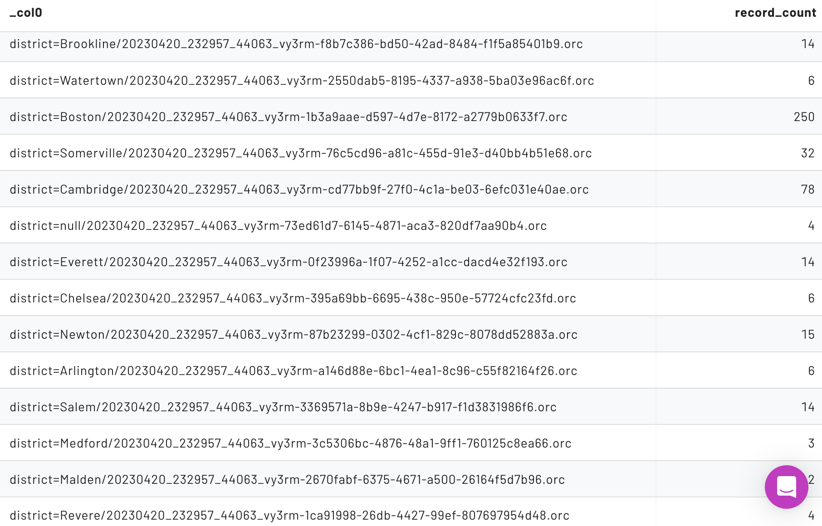

You should also notice that the partition directory naming scheme is similar to that of the Hive table format. They both use the name=value format for the subdirectories.

Step 10 - Query partitions table
Review the Iceberg metadata tables. Iceberg tables include a $partitions table.

Use the code listed in the image below to query the $partitions table.

Note: The total number of records for each partition will be easier to obtain from this query than the prior one when we have more than a single file per partition.

SELECT * FROM "stations_p_district$partitions";

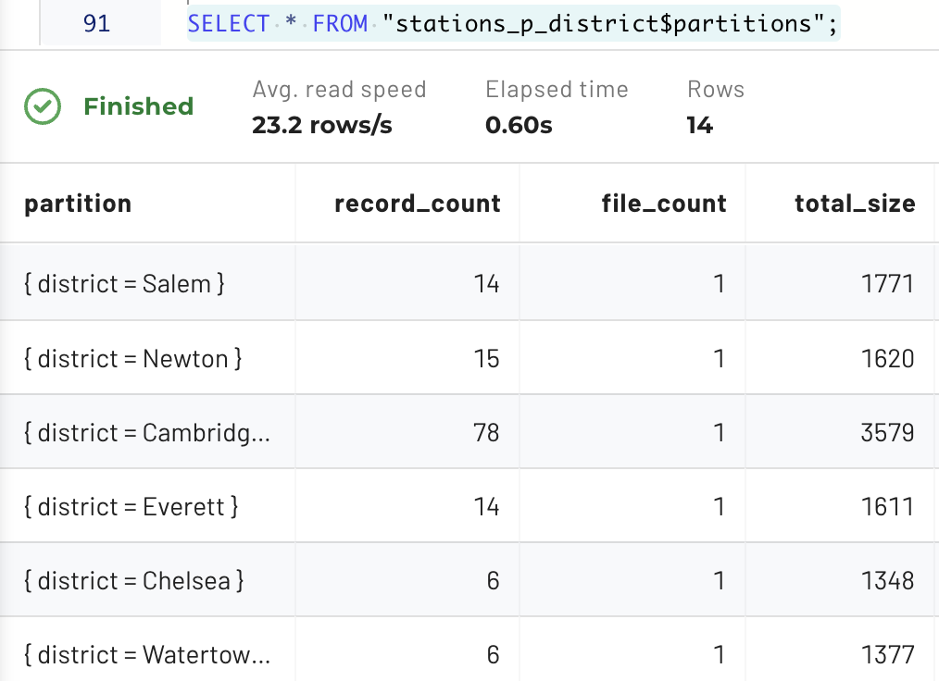

Now look at the data column. It represents the column-level statistics across all the data files in a given partition folder.

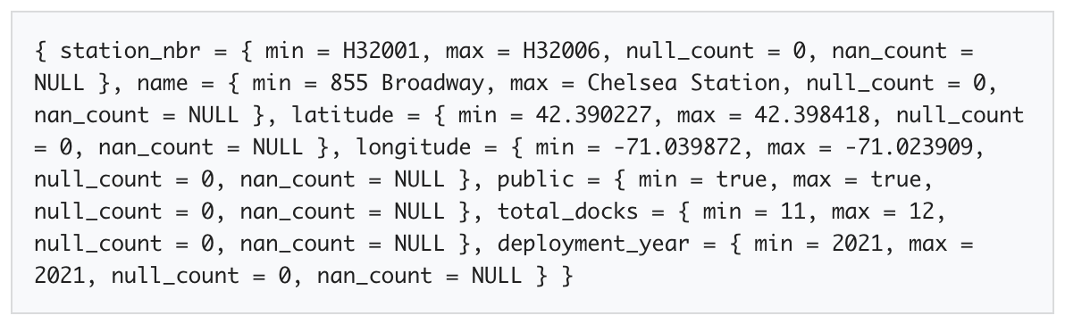

Step 11 - Reformat output
With some simple formatting, it is easier to consume the column-level metadata for a particular partition.

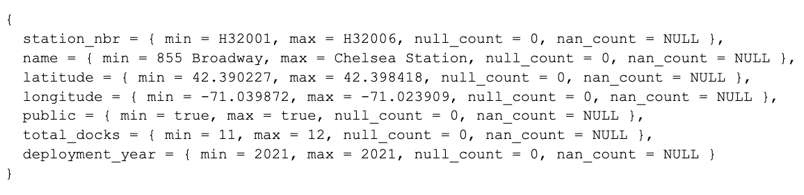

Since the partitioning was defined on the district column, Iceberg does not need to store any column statistics for that particular column. Mainly because there is only a single value, the district value, for the whole partition. The example above was from district=Chelsea.

Step 12 - Query trips table
It’s time to turn your attention to the lakehouse.bluebikes.trips table. SELECT all records from the table using the code below.

SELECT * FROM lakehouse.bluebikes.trips;

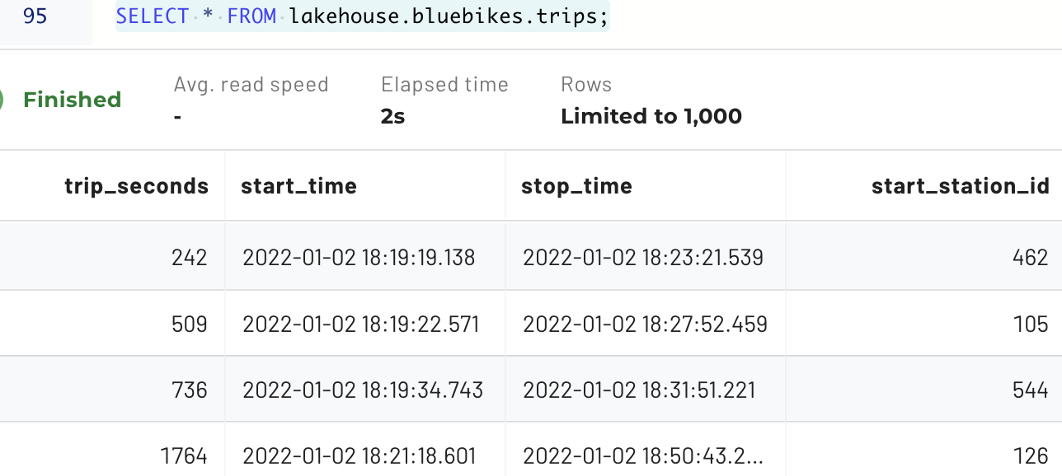

Notice that the timestamp fields listed correspond to the start of each ride.

Step 13 - Partitioning start_time field
You know that the start_time data is immutable. You also know that many analytic queries include a filter targeting trips within a range of 1-180 days.

Based on these facts, it would be a good idea to consider partitioning based on the start_time field. Importantly, you cannot use discrete values to do this. This approach would be too granular and create too many folders containing only a single trip, introducing the small files problem.

Step 14 - Understanding conditional logic and the WHERE clause
Adopting a partitioning strategy based on month would be best in this case. The Hive table format allows you to abstract the level of precision from the start_time field and put that value in a new, partitioned column. The result will be a start_time_month field with a value format of YYYY-MM.

To use this approach efficiently, you will need to understand how these two columns are best utilized, balancing precision against efficiency. The goal is to target the smallest amount of data possible while still achieving a good result.

More directly, the Hive table format often causes confusion in scenarios like this by having two different columns (start_time and start_time_month) representing the same information.

Step 15 - Create partitioned table
Iceberg offers a much simpler solution to solve the problem in the previous step. The approach in the DDL below shows there are timestamp-based transform functions that can be used that do not require you to actually create & populate another dedicated column to achieve partitioning at a more coarse-grained level such as at the month level.

The user then does not have the opportunity to get confused about having two similar, but functionally different, date/timestamp fields. The user just applies the appropriate WHERE clause on the timestamp field.

Create a new table, partitioned by month using the code below.

CREATE TABLE trips_p_start_month (
trip_seconds integer,
start_time timestamp(6),
stop_time timestamp(6),
start_station_id integer,
start_station_name varchar,
start_station_latitude decimal(15, 13),
start_station_longitude decimal(16, 13),
end_station_id integer,
end_station_name varchar,
end_station_latitude decimal(15, 13),
end_station_longitude decimal(16, 13),
bike_id integer,
user_type varchar,
postal_code varchar
)
WITH (
type = 'iceberg',
format = 'ORC',
partitioning = ARRAY['month(start_time)']
);

Step 16 - Copy data into table
Now it’s time to copy the original data into your new table. Use the code below:

INSERT INTO trips_p_start_month
SELECT * FROM lakehouse.bluebikes.trips;

Step 17 - Apply conditional logic using WHERE clause on source table
From the source table from the prior query, lakehouse.bluebikes.trips, determine how many trips were started in March 2022.

SELECT COUNT(*) FROM lakehouse.bluebikes.trips
WHERE start_time >=
from_iso8601_timestamp('2022-03-01T00:00:00')
AND start_time <
from_iso8601_timestamp('2022-04-01T00:00:00');

You will see there are 182,421 results from that time range on the original table.

Step 18 - Compare results with newly partitioned table
Compare those results from what is seen in the $partitions metadata table. Use the code listed below.

SELECT * FROM "trips_p_start_month$partitions";

You can see that the start_time_month= partitions are not as straightforward as the purpose-built ones that you saw previously. The documentation notes the following:

Note: A partition is created for each month of each year. The partition value is the integer difference in months between the timestamp and January 1, 1970.

January 1, 1970, is the date known as the Unix Epoch, which is used as the start date for many systems, including this one. In your case, there are 52 years and 2 months before March 1, 2022 and the Unix Epoch, so the number you are looking for is 626. (12 * 52 + 2 = 626).

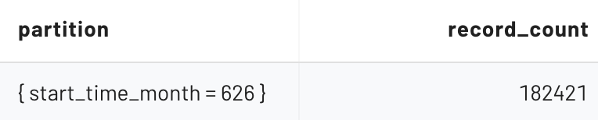

This shows the metadata table identifying the correct number of records for the month of March 2022 from the appropriate partition of the newly partitioned table that we saw from the source table in Step 17.

Run the query again, this time on the partitioned table, to make sure the same 182,421 count is being returned.

SELECT COUNT(*) FROM trips_p_start_month
WHERE start_time >=
from_iso8601_timestamp('2022-03-01T00:00:00')
AND start_time <
from_iso8601_timestamp('2022-04-01T00:00:00');

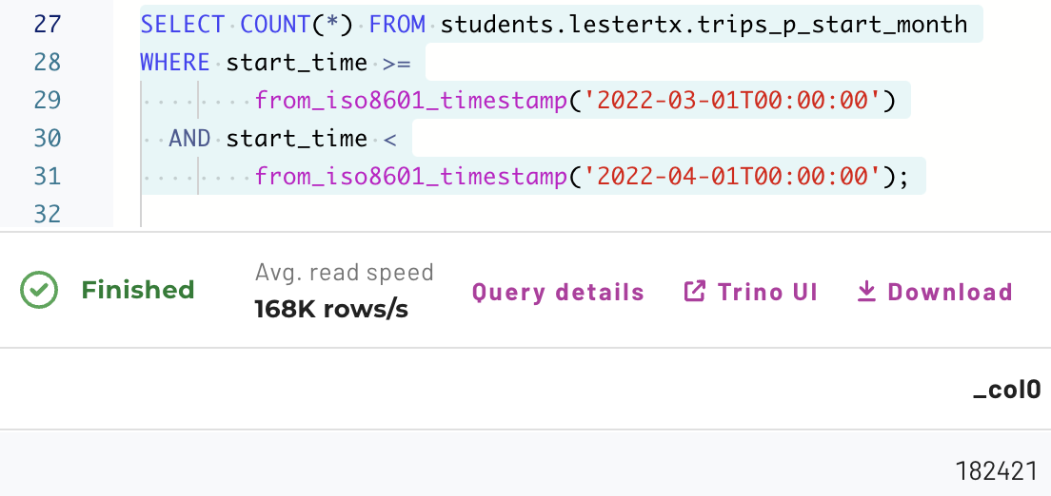

END OF LAB EXERCISE

